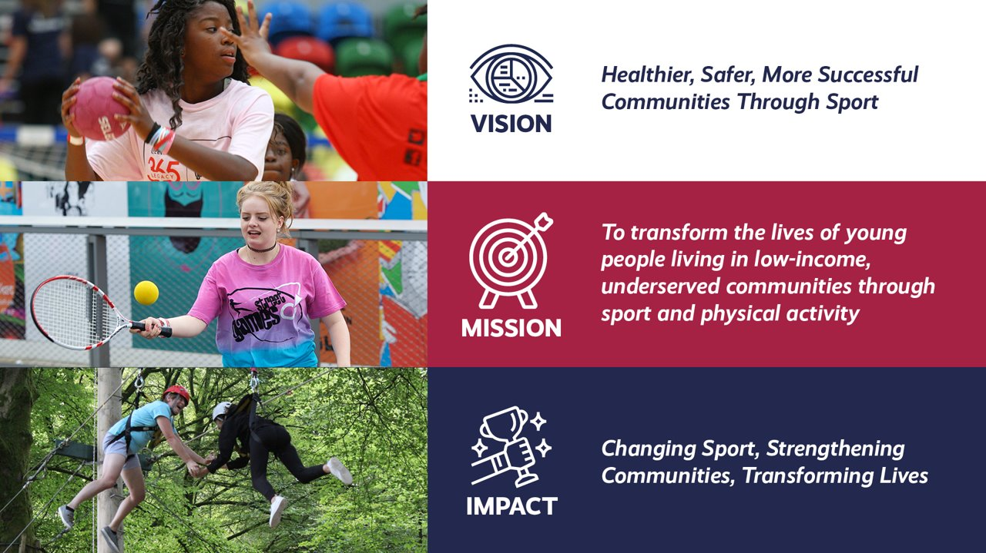
StreetGames UK

National Workforce Lead

This role is offered full time at 35 hours per week. Other options such as
job-share or part-time arrangements will be considered. Secondment
opportunities can also be discussed.

Information pack

“…the sports charity that brings sport to the doorstep of young people in underserved communities across the UK”

Background StreetGames is a national sport and anti-poverty charity working to address inequalities prevalent to those living in the most underserved communities. StreetGames do this through a network of community organisations and partners who work to mobilise ‘Doorstep Sport’ – sport delivered at the right time, in the right place, in the right style, at the right price and by the right people. Doorstep Sport aims to make sport accessible to everyone regardless of their income and social circumstance.

StreetGames Values

We hold a set of shared values, through the community of talented people, who work for StreetGames. We hold each other accountable to these values and ensure that we live our values when working with external partners and/or young people.

We are:

People-centred

People are at the heart of everything we do.

Passionate

About making a difference for children and young people living in low-income, underserved communities.

Positive

In our approach to every area of our work. We back ourselves to find solutions even when things are challenging.

Pragmatic

About the approaches we need to take, to tackle the inequalities for young people living in low-income, underserved communities; the world is not perfectly designed and we find a way.

Courageous

In our approach to creating change. We positively disrupt and challenge in the pursuit of our mission

Our commitments to each other

StreetGames is a special place to work. Our workplace is a community of talented people, who work in innovative ad co-productive ways. How we work together reflects a commitment we make to each other.

We are committed to:

Respecting everyone – valuing every member of our workplace community, treating each other as equals and with kindness.

Being inclusive – celebrating the diversity in our workplace community, valuing each other’s experiences, skills, expertise, preferences and thoughts.

Being collaborative – working with others, seeking to utilise the skills and experience of many. Sharing our learning, our ideas and listening, so we achieve the best outcomes for Locally Trusted Organisations (LTOs) and young people.

Being team players – being reliable for each other. Supporting one another to achieve. Creating an environment where people feel included, empowered, able to be creative and are supported on their StreetGames journey.

Being collaborative – working with others, seeking to utilise the skills and experience of many. Sharing our learning, our ideas and listening, so we achieve the best outcomes for Locally Trusted Organisations (LTOs) and young people.

Learning together – embracing critical thinking, celebrating success, encouraging challenge, whilst drawing out learning. Then applying our learning, so we can make the biggest impact to young people, though Doorstep Sport, together.

Acting with integrity – championing the highest organisational standards. Being greatly aware of our individual accountability and responsibility. Doing what we say we are going to do and holding ourselves and each other to high standards.

Being Agile – by being curious, thinking flexibly and creatively and seeking new opportunities. We pro-actively adapt and provide meaningful support, when these new opportunities arise.

Being the People besides the People – making decisions in the best interest of the LTOs and the young people we support and represent, so they reap the benefits of Doorstep Sport.

The Role

National Workforce Lead
Salary range, £36,767 - £41,924 (SCP 33 – 38)
Ideally Manchester based with National travel, but will consider remote working

StreetGames is a fast-moving and innovative national charity with a sector-leading reputation for delivering sport and physical activity on the doorstep of deprived communities.

Our aim is to help young people and communities enjoy lives that are healthier, safer and more successful through sport and physical activity.

To do that, we work with community organisations to engage young people from lower socio-economic groups through sport and physical activity at the right time, in the right place, at the right price, in the right style and through the right people.

Who are we looking for?
StreetGames is looking for candidates who will be able to demonstrate experience and understanding of quality training delivery, content development skills and the ability to implement internal quality and development processes across a national training academy, managing a varied workload.
Candidates should be able to support and develop those around them and should be innovative, collaborative and able to adapt to a quickly moving organisation. They should also be detail orientated and able to work with a wide range of internal and external teams, networks and partners.
This role is offered full time at 35 hours per week. Other options such as job-share or part-time arrangements will be considered. Secondment opportunities can also be discussed.
No candidate will meet every single desired requirement. If your experience looks a little different from what we have identified and you think you can bring value to the role, we would love to learn more about you!
Applying for the role

The Job Description and Person Specification are included in this information pack.

Please email your completed application form to jobs@streetgames.org quoting ‘National Workforce Lead’ in the subject line.
If you have any questions relating to these posts, or would like an informal chat please contact:
Jess Callaghan (Head of Workforce Development) jess.callaghan@streetgames.org or call 07983 538 374
The closing date for applications is Monday July 3rd 2023 at 9:00am
Shortlisting will take place 3rd – 5th July with interviews taking place on July 13th 2023 in central Manchester.
If you know you will be unavailable on the interview date above, please state this on your application form.
If you would need any additional requirements, please also state this on your application form.
StreetGames is fully committed to the principles of equality of opportunity and is responsible for ensuring that no job applicant, employee, volunteer or member receives less favourable treatment on the grounds of age, gender, disability, race, ethnic origin, nationality, colour, parental or marital status, pregnancy, religious belief, class or social background, sexual preference or political belief.
StreetGames is committed to safeguarding and promoting the welfare of children and vulnerable adults, and expects all employees and volunteers to share this commitment.
