# StreetGames UK

# **Funding and Partnerships Manager North West**

# **Information pack**

# 

# “…the sports charity that brings sport to the doorstep of young people in underserved communities across the UK”

### Background StreetGames is a national sport and anti-poverty charity working to address inequalities prevalent to those living in the most underserved communities. StreetGames do this through a network of community organisations and partners who work to mobilise ‘Doorstep Sport’ – sport delivered at the right time, in the right place, in the right style, at the right price and by the right people. Doorstep Sport aims to make sport accessible to everyone regardless of their income and social circumstance. We are wish to ensure the active participation of Young Women, Black, Brown and Ethnically marginalised young people, and LGBTQ+ young people in the North West.

**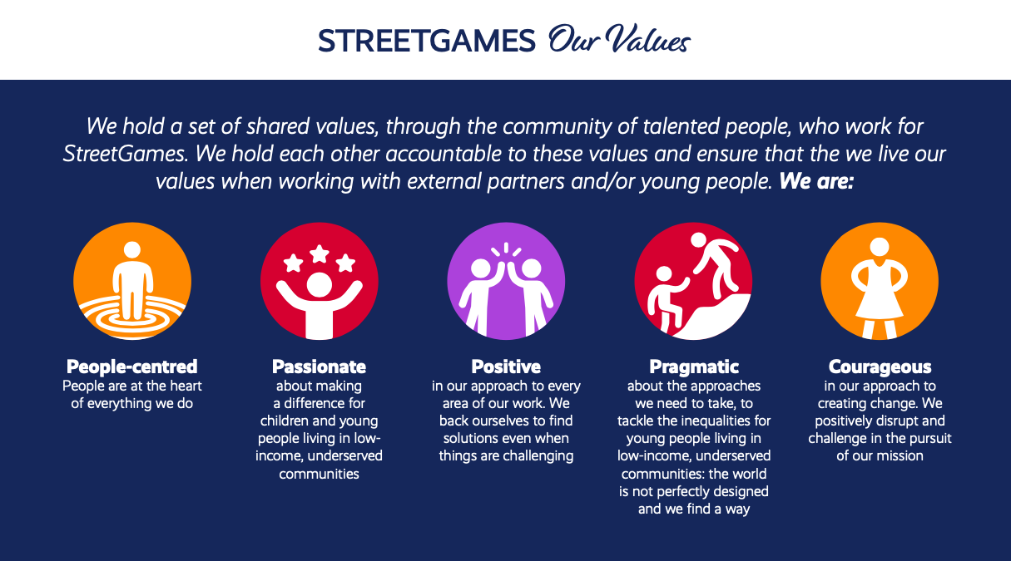**

**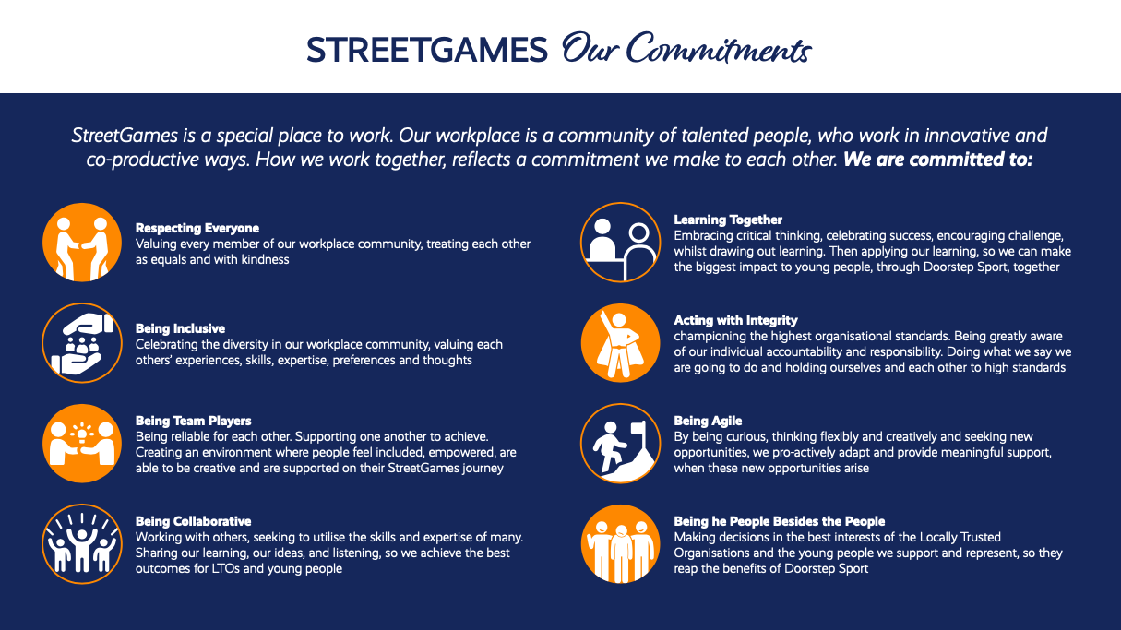**

**The role**

**Funding and Partnerships Manager North West. Salary range, £41,924 – £49,123 (pro rata for 4 days)**

StreetGames is a fast-moving and innovative national charity with a sector-leading reputation for delivering sport and physical activity on the doorstep of deprived communities.

Our aim is to help young people and communities enjoy lives that are healthier, safer and more successful through sport and physical activity.

To do that, we work with community organisations to engage young people from lower socio-economic groups through sport and physical activity at the right time, in the right place, at the right price, in the right style and with the right people.

The role of the **Funding and Partnerships Manager North West** will form a crucial part of our approach to growing participation in sport among young people from the communities we work in. Working in an Area Team, reporting to the Area Lead and collaborating closely with local Doorstep Sport Advisors, Fieldworkers, and Workforce Lead, the **Funding and Partnerships Manager North West** role will help community organisations to access new sources of income for the delivery of the local sporting offer, through their ability to link the needs of investors in wider social outcomes with community organisations’ capability.

The **Funding and Partnerships Manager North West** will support both the national and regional work of the StreetGames Fundraising Team; ensuring national priorities are reflected in local work undertaken with groups of organisations and individual community organisations and also securing direct investment and funding for the StreetGames charity.

**Who are we looking for?**

StreetGames is looking for candidates who recognise and bring to life our values of People-centred, Passionate, Positive, Pragmatic and courageous.

StreetGames is looking for candidates with experience of successfully developing collaborative funding bids, and proposals, working with multiple partners.

You will have excellent networking and Partnerships building skills, with the ability to apply these to a range of local, regional and national organisations.

With strong written communication skills, you can write concise and coherent funding bids, drawing on your experience of working with a range of different funders and stakeholders.

You will also be an excellent Partnerships builder and manager, with experience of working collaboratively with funders and partners.

As the successful candidate you will be a self-starter maximising your excellent communication and people management skills.

You will be able to manage budgets, produce reports and update financial systems.

You will be outcomes and solution focussed, possessing a good knowledge of wider social outcomes, and ways to address them, for people living in the communities we interact and work with through sport and physical activity.

StreetGames currently supports a broad range of Locally Trusted Organisations (LTOs), who are members of the StreetGames network, and we are keen to ensure good support for activities that enable women and girls, LGBTQ+ young people and Global Majority young people to feel part of our Doorstep Sport approach.

This role is offered at 0.8FTE (28 hours per week). Other options such as job-share, part-time or term time arrangements will be considered.

No candidate will meet every single desired requirement. If your experience looks a little different from what we have identified and you think you can bring value to the role, we would love to learn more about you!

**Applying for the role**

The Job Description and Person Specification are included in this information pack.

Please email your completed application form/CV and covering letter to [jobs@streetgames.org](mailto:jobs@streetgames.org) quoting **Funding and Partnerships Manager North West** in the subject line.

If you require any additional support completing your application, please contact [jobs@streetgames.org](mailto:jobs@streetgames.org) and we will try and accommodate any reasonable requests.

If you have any questions relating to the role, or would like an informal chat please contact:

Sally Carr [sally.carr@streetgames.org](mailto:sally.carr@streetgames.org) or call 07485 394774

The closing date for applications is9am on Monday 2nd October

Interviews will take place on Friday 13th October and Wednesday 18th October 2023

If you know you will be unavailable on the dates above, please state this on your application form.

|  |
| --- |
| *StreetGames is fully committed to the principles of equality of opportunity and is responsible for ensuring that no job applicant, employee, volunteer or member receives less favourable treatment on the grounds of age, gender, disability, race, ethnic origin, nationality, colour, parental or marital status, pregnancy, religious belief, class or social background, sexuality or political belief.* |

*StreetGames is committed to safeguarding and promoting the welfare of children and vulnerable adults, and expects all employees and volunteers to share this commitment.*

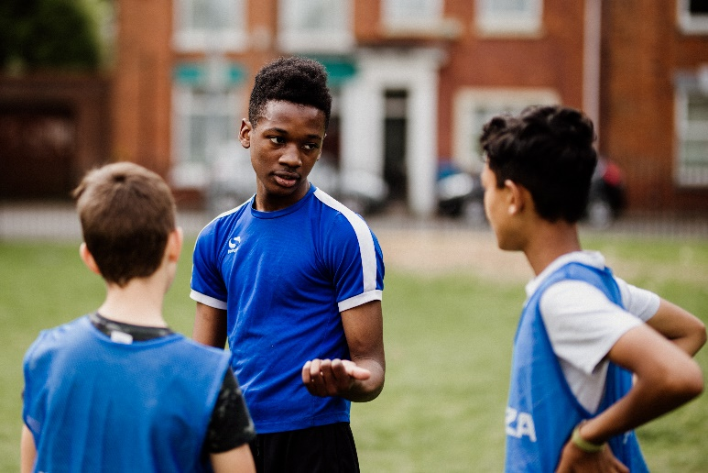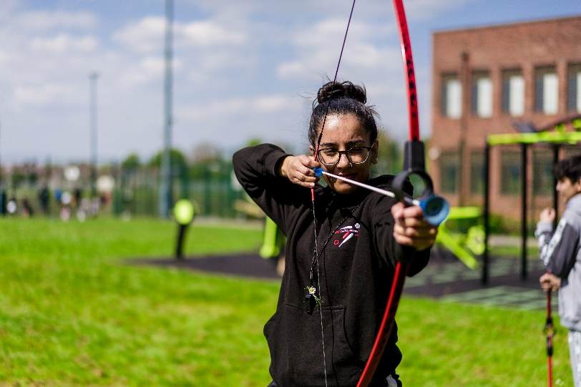

|  |  |  |
| --- | --- | --- |
| **JOB DESCRIPTION AND PERSON SPECIFICATION-Funding and Partnerships Manager North West** | | StreetGames_Logo |
| **StreetGames** | **Location: Hybrid NW Region/Mcr office** | | |
| **Job Title:** **Funding and Partnerships Manager North West England** | **Grade/Salary Range:**  **Employed posts (0.8 FTE):**  **Secondments and other arrangements negotiable.**  **Salary Band: PO3/4 £41,924 – 49,123 (pro rata for 4 days)** | | |
|  |  | | |
| **JOB PURPOSE** | | | |
| The **Funding and Partnerships Manager North West** will form part of the StreetGames North West regional team, and will work alongside the Area Director, Fieldworkers, Workforce Lead, Doorstep Sport Advisors, freelance staff and cross organisational team, to develop and support the financial sustainability of Locally Trusted Organisations (LTOs), StreetGames in the region and centrally, and the funded delivery of Doorstep Sport across the region. The post holder will also be a member of the national StreetGames fundraising and sustainability team.  StreetGames has a reputation for delivering doorstep sport in deprived communities. Our five rights approach ensures young people engaging through sport, delivered in the right style, in the right place, at the right time, for the right price and with the right people; to help them lead an active lifestyle and achieve their potential.     * The **Funding and Partnerships Manager North West** will support and enable LTOs, and StreetGames, to access new sources of income, for the delivery of the local sporting offer through their ability to link the needs of investors to wider social outcomes, and enhance community organisations Partnerships with key funders. * The **Funding and Partnerships Manager North West** will build the fundraising capacity within LTOs and StreetGames North West, to support their long-term sustainability. * The **Funding and Partnerships Manager North West** will support both the national and regional work of the StreetGames Fundraising Team; ensuring national priorities are reflected in local work undertaken with LTOs individually, and in regional groups where appropriate. | | | |
| **MAIN DUTIES AND RESPONSIBILITIES** | | | |
| **Main Duties and Responsibilities**   1. Undertake research to identify regional and local funding opportunities for both StreetGames and LTOs. 2. Establish and develop partnerships with key regional stakeholders and funders in relevant areas of social policy, including sport, youth & community, community safety, health, regeneration, employment & skills and housing. 3. Provide support to LTOs to help them produce strong, evidence based grant applications and funding proposals that result in increased levels of investment and sustainability. 4. Be the lead area team member in co-ordinating and writing grant applications, bids for contracts and project proposals that secure funding and resources to support the sustainability and growth of StreetGames UK. 5. Support the development of new evidence that will demonstrate the impact of Doorstep Sport and utilise this impact to attract new funders. 6. Deliver fundraising and bid writing training to LTOs, utilising the resources of the StreetGames Sustainability Support Programme. 7. Where appropriate, be able to apply national fundraising priorities locally and regionally. 8. Work with North West Team to understand the priorities emerging from the local data and LTO’s in relation to sustainability. 9. Work with local and regional grant-making Trusts and Foundations to broker application access to grant programmes. 10. Manage budgets, produce reports and update financial systems. 11. Work with local and regional business networks (industry networks, local chamber of commerce etc.) and companies to create opportunities for donors to engage with LTOs. 12. Leverage investment opportunities, support LTOs to identify match-funding opportunities and help them to achieve the levels of good governance that provide grant giving organisations and commissioners with confidence to provide investment. 13. Use their knowledge and experience of different types of community organisations and how they operate to provide appropriate support and guidance in relation to fundraising and sustainability planning. 14. Develop a comprehensive understanding of the local priorities of LTOs and match them to different funding opportunities. 15. Disseminate knowledge, insight and good practice on a regular basis. 16. Identify where common themes exist and look at ways of creating joint workshops / funding clinics. 17. Look for opportunities to grow and develop this support service through partnerships with other agencies and networks, including Active Partnerships, community foundations, Sported and youth networks. | | | |
|  | | | |

|  |  |  |  |
| --- | --- | --- | --- |
| **PERSON SPECIFICATION** | | |  |
|  | | |  |
| **StreetGames** | | **Job Title: Funding and Partnerships Manager North West** | |
| **The Funding and Partnerships Manager North West** will ensure a values led approach to their work, reflecting the StreetGames values of People-centred, Passionate, Positive, Pragmatic and courageous.  **Funding and Partnerships Managers** are knowledgeable, enthusiastic and passionate about organisations working with young people from the most deprived communities and providing sport and physical activity in a style that will engage now and have a lasting impact on those people’s lives.  **Funding and Partnerships Manager** will be part of an Area Based Team, along with an Area Director, Fieldworker, Workforce Lead, Freelancer worker and Doorstep Sport Advisors. Together they will use their expertise, local knowledge and inter-personal skills to build positive Partnerships with the people and projects within a defined area and the funders who are able to support this work.  The **Funding and Partnerships Manager** willcontributeto the development of StreetGames work in the area of fundraising and partnerships as a member of the national Fundraising & Sustainability team.  The **Funding and Partnerships Manager** will provide the necessary advice, guidance, information and support, to improve the sustainability of the sporting offer through network-working.  **Funding and Partnerships Manager** will have experience and expertise in fundraising with a specific emphasis on developing and writing collaborative funding bids. | | | |
|  | | |  |
| **Experience:** |  | |  |
| 1. Experience and understanding of working with community organisations within areas of poverty and deprivation 2. Experience of writing successful funding applications, to a diverse range of funders. 3. Experience of leading collaborative funding bids involving multiple partners. 4. Experience of brokering and developing positive working Partnerships with a diverse range of national, regional and local funders and partners 5. Experience of undertaking research and maintaining appropriate records that could be applied to national, regional and local funding opportunities. 6. Experience of capturing and sharing learning to demonstrate impact 7. Experience of applying national fundraising priorities to regional and local environments. 8. Experience of identifying training needs of organisations, and establishing appropriate fundraising / bid writing training, to meet those needs. 9. Experience of Manage budgets, produce reports and update financial systems. | | | |
| **Skills and Abilities:** |  | |  |
| 1. Values led approach reflecting StreetGames values of People-centred, Passionate, Positive, Pragmatic and courageous. 2. Excellent interpersonal communication skills; presenting ideas and information, providing clear instructions, persuading and negotiating. 3. Excellent research and data collection skills. 4. Excellent written communication skills with the ability to produce strong, coherent funding applications as well as written reports, development plans and support materials for local organisations. 5. Excellent Partnerships management skills with the ability to engage a wide variety of strategic and delivery partners. 6. Excellent customer care skills with the ability to develop these in others. 7. Excellent organisational skills, able to manage all aspects of a diverse regional programme. 8. Able to use own initiative and work without direct supervision 9. Able to prioritise workload effectively and deal with competing and conflicting priorities. 10. Strong teamwork skills with the ability to lead and play a role within a team, including motivating colleagues and team members. 11. Able to use Word, Excel and Powerpoint and email effectively. 12. Able to learn the use of new IT packages e.g. CRM systems. 13. Able to interpret statistical information from a range of sources and create coherent reports. 14. Able to manage budgets, produce reports and update financial systems. | | | |
| **Work Related Personal Requirements** |  | |  |
| This post may be subject to a Disclosure and Barring Service check.  The post holder must be able to travel for work purposes.  There may be occasions where an overnight stay is required for work purposes. | | | |