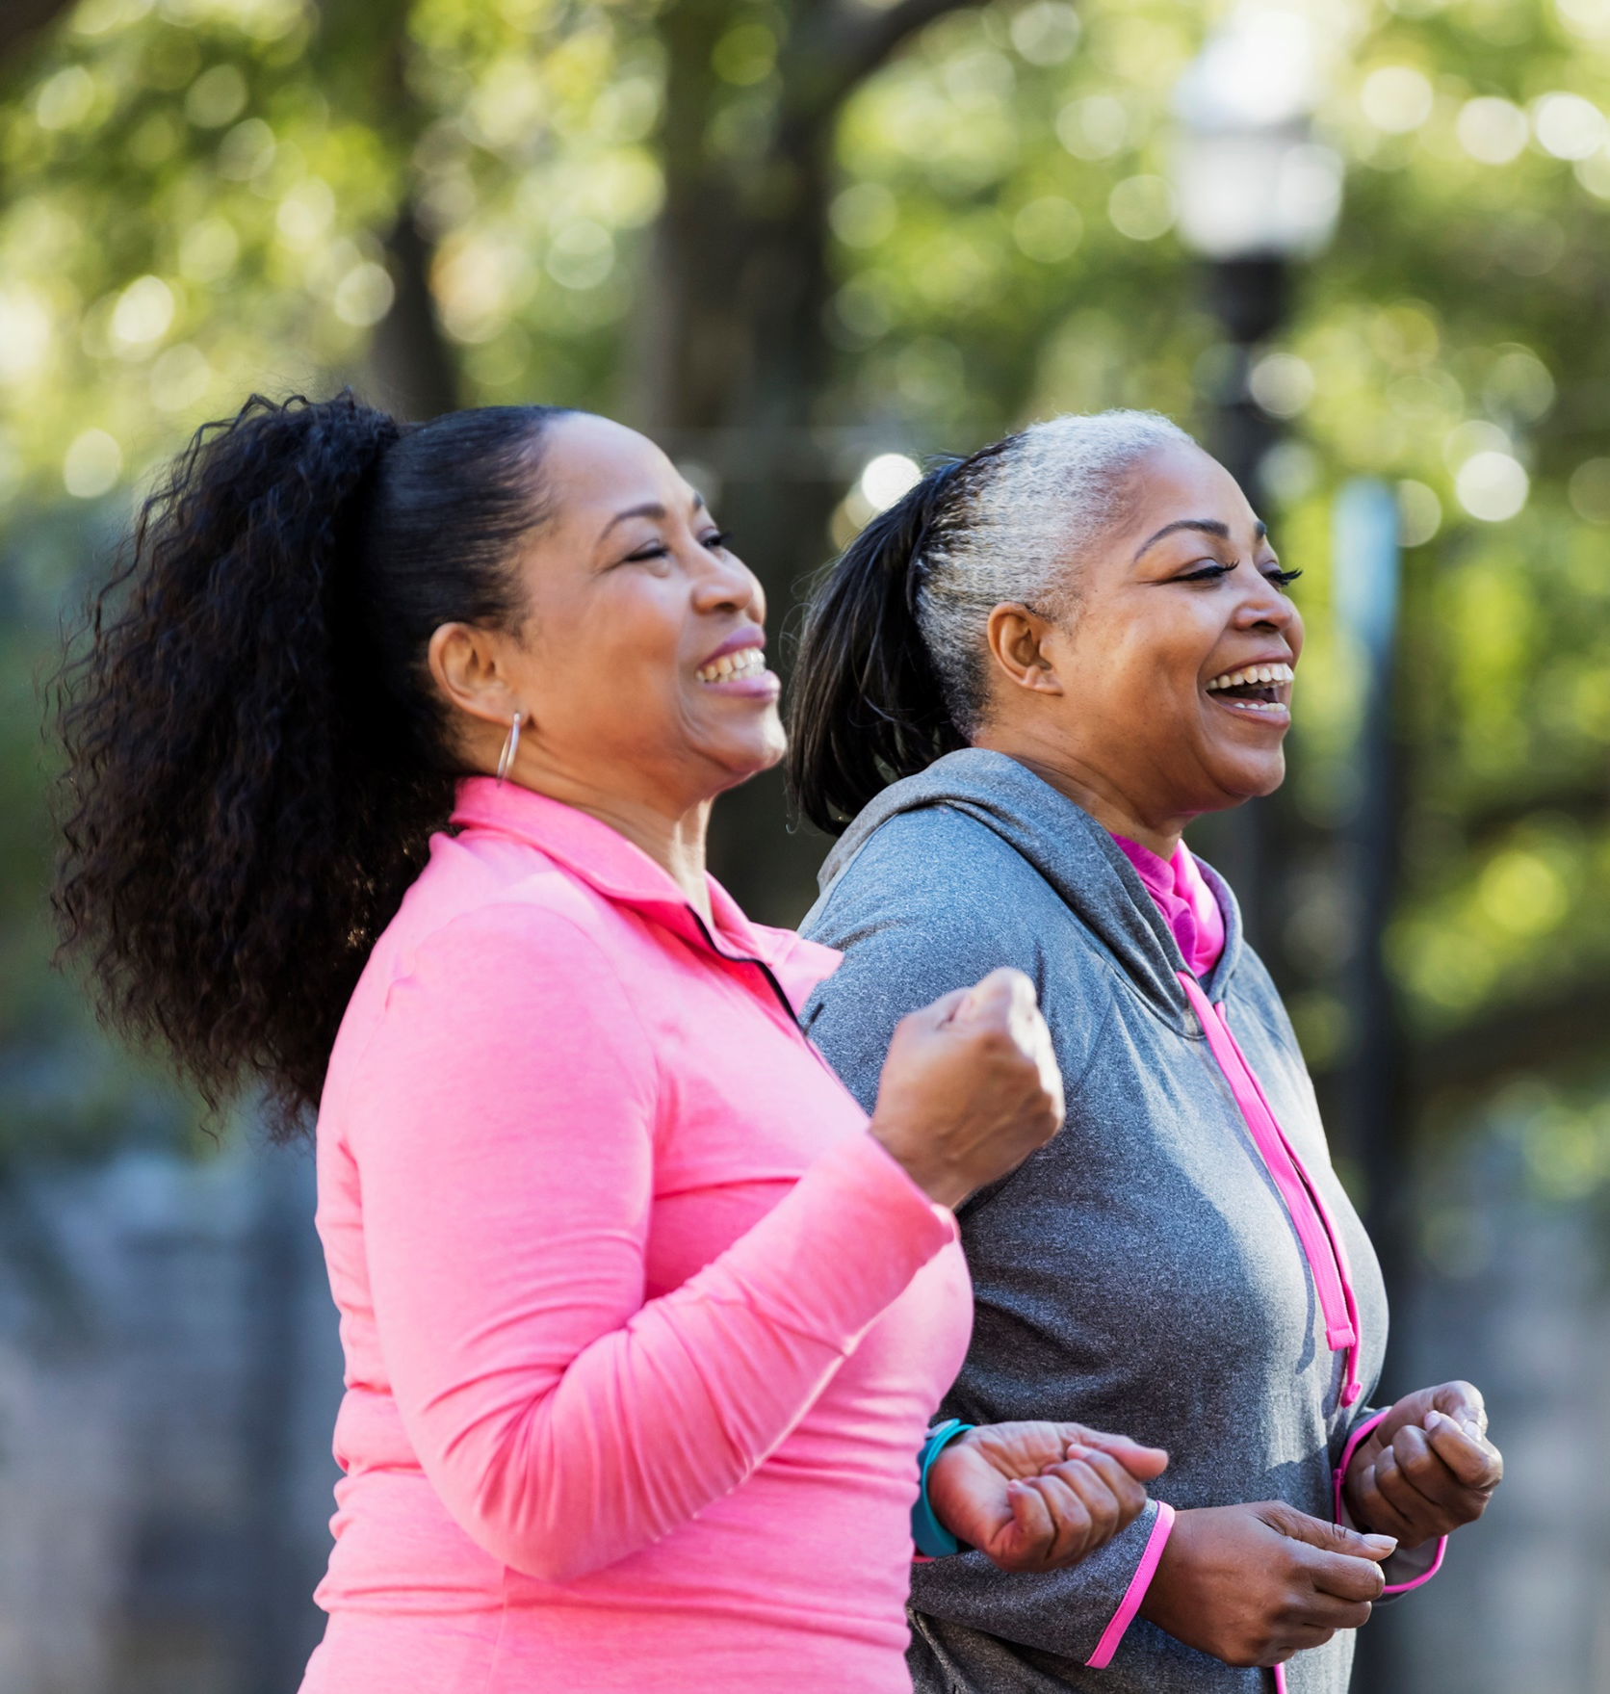
Active Listening
Hull’s conversation about physical activity

Active Listening
Phase 1 Engagement Brief
Objective
To use a range of tools and approaches to gather qualitative data that details people’s views and opinions about physical activity.
Project Overview
Partners across the city are trying to identify how people in Hull can engage more in Physical Activity (Any bodily movement which expends energy.) The benefits of Physical activity are well documented and have a profound impact on peoples physical and mental health. However, there are also a host of reasons why somebody is inactive. It is important we understand what drives people’s current levels of activity so that as a city we can make changes to create a healthier environment for people to be active and reach their potential.
Approach & Methodology
To gather a range of views we would like services to work in a dynamic way. Services can drive forward their engagement to ensure the views of the population they serve are captured. The themes will serve as a framework to support the engagement. At this stage however, we know that conversations will be broad and we encourage facilitators to explore conversations with residents around the themes provided.
Target Audience
The engagement is for anybody who either lives, works or plays in the city of Hull. Those who are not physically active or have high levels of inactivity in addition to the seldom heard would be recognised as priority participants
Timescales
The Engagement in Phase 1 is to take place before March 14th, 2025. Engagement can start as soon as is possible.
Reporting Back
Please report back in periodically no more than monthly to ensure a line of sight between the working group and the feedback and data that is being collected.

Themes to explore
Defining Physical Activity PERCEPTION
Exploring what people’s perception is of physical activity, how do they perceive the behaviours of somebody who is physically active?
- What do you consider as physical activity?
- What behaviours do you consider somebody who is physically active to have?
Activity levels ASSESSMENT
This would allow us to assess current levels of physical participation. The good and the bad, those that are active and those that are inactive. This will give us a base level in addition to some of the enablers or barriers.
- How active are you?
- What do you enjoy doing that is physically active?
- What stops you from being as active as you would like?
- What is one thing you could do tomorrow to make you more active?
Active places FUTURE
This will allow for some future thinking around place, the environmental conditions that will encourage people to be more active.
- What would you like to see in your community that would make you more active?
- What could Hull do to encourage more people to be Physically active?
- What environmental barriers exist in Hull to stop people being physically

